You will create your own cartoon explaining Newton’s 3rd Law.
You must include the following terms: action/reaction, equal, opposite, contact forces, Newton’s 3rd Law.
Provide a detailed explanation of how your cartoon describes all the key terms. Underline the key terms.
You only need one box

For example:

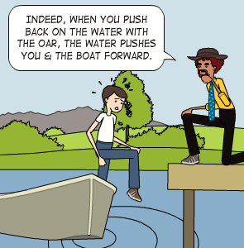

The action is he is pushing on the boat trying to get out. The reaction of the water is equal to the push of that requires contact George. These are opposite forces, which explains Newton’s 3rd Law.

