Motion and Forces Terminology Assignment

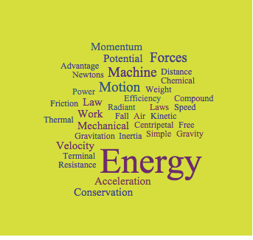
Look at this word cloud – it contains the scientific terms we have been using in class this year.

Now – find a short video clip about a topic that interests you that you can use some of the terms listed above to explain. Ideas – sports, rides, cars, planes, etc…

Create a word document with a title, a link to the video, and a paragraph explaining how some of the terms listed above are applied in the video. Highlight the words that you use from the collage.

