Physics Name:
Unit 9: Magnetism – Magnetic Fields Date:

Use a compass to accurately represent (map) the magnetic field.

1. Single Magnet (North and South Poles)

[OVER]

Two bar magnets with opposite poles close together.

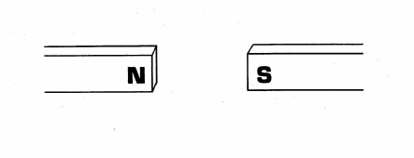

Two bar magnets with similar poles close together

