Review for Unit 4 test
F_{net} = ma F_{f} = µF_{N} F_{e}=k∆x F_{c}= mv²/r V₁²=V_{o}² +2a∆x

Answer the following questions with providing your work (how did you derive the answer) and circle your answer. Do NOT forget provide units for your answer.

1. Calculate the force required to speed up a bowling ball that weighs 74 N at a rate of + 20 m/s².

2. What is the estimated acceleration due to the gravitational force on the moon if a person on Earth weighs 550 N - but only 75 N on the Moon?

3. A rider on a motorcycle with a combined mass of 300 kg are going down the road at 40 m/s. The rider wants to stop and applies the brakes until coming to rest. What force will the brakes need to apply in order for the rider to stop in a distance of 150 m?

4. Suppose a net force of 34 N is applied horizontally while pushing a desk weighing 545N. Assuming there is no friction, what is the displacement of the desk after 10 seconds?

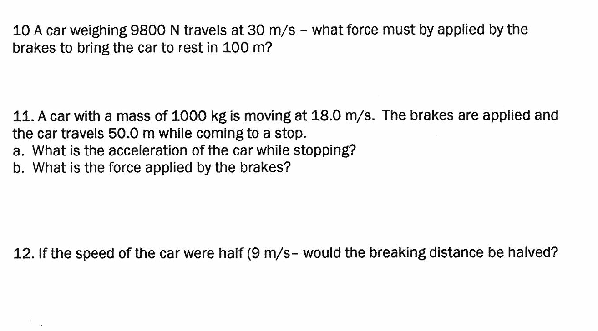

8. A force of 15 N is exerted to the right on a 30 N wooden crate in an attempt to move a box across a wooden floor, which has a coefficient of friction of 0.30.
What is the force of friction between the floor and the crate?

9. What is the spring constant if a spring averages a stretch if 0.1 meter when a 7 Newtons of force is applied?

